
Sec 7.10 – Minimum Spanning Trees
Networks & Graphs Name:
- Create a spanning tree using the breadth-first search algorithm. Start at A (i.e. 0) and label each vertex with the correct number after A and show your path.
J
A
C
B
D
E
F
G
H
I

How many edges were used to create a spanning tree?

J
A
C
B
D
E
F
G
H
I

- Create a spanning tree using the breadth-first search algorithm. Start at G (i.e. 0) and label each vertex with the correct number after A and show your path.

How many edges were used to create a spanning tree?

J
A
C
B
D
E
F
G
H
I
- Create a spanning tree using the breadth-first search algorithm. Start at J (i.e. 0) and label each vertex with the correct number after J and show your path.

How many edges were used to create a spanning tree?

Student Worksheets Created by Matthew M. Winking at Phoenix High School SECTION 7-10 p.104

B
C
D
E
G

I

J

A
H
- Create a spanning tree using the breadth-first search algorithm. Start at A (i.e. 0) and label each vertex with the correct number after A and show your path.

- 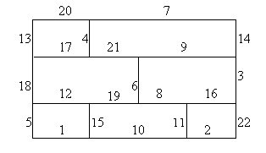The minimum cost spanning tree found using Kruskal’s algorithm for the following graph has a cost of____.

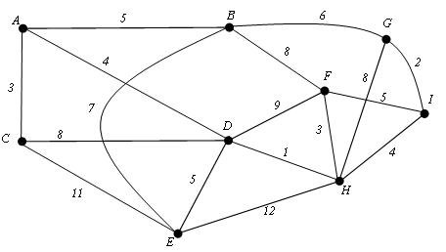
- Create a minimum spanning tree using the Kruskal’s algorithm. What is the total minimum length of the spanning tree?

Student Worksheets Created by Matthew M. Winking at Phoenix High School SECTION 7-10 p.105

